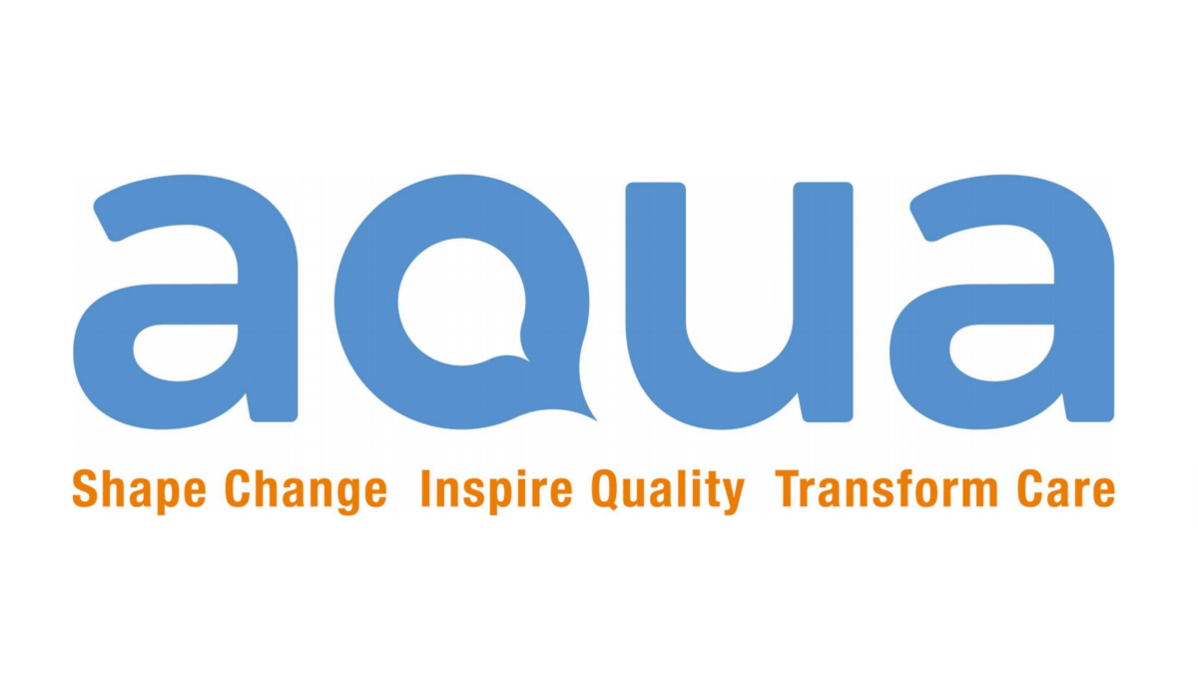

Lived Experience Panel Member Application Form.
Note: The information you supply will be dealt with in confidence. Please refer to the role spec when completing your application.

Name

Address

Postcode
Township Please select | Rochdale North/Rochdale South/Pennines/Heywood/ Middleton
Email

Contact phone number
Date of Birth

Declaration of Interests
Do you have any business or personal interests that might be relevant to the work of the Lived Experience Panel which could lead to a real or perceived conflict of interests were you to be appointed? (Failure to disclose such information could result in an application being terminated).
Yes No
If yes, please give details below

- Please tell us about yourself and why would you like to join the Lived Experience Panel group?

- What understanding do you have of Northern Care Alliance?

- What are your personal experiences with health and social care services?

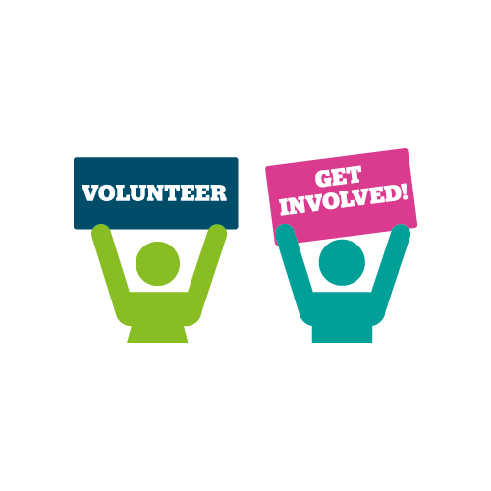
NB: Closing date for applications is Monday 15th March 2021, Interviews are on Wednesday 17th March 2021

Please tick or highlight

- I confirm that the information given in this form is correct to the best of my knowledge and understand that any false statements or missing information would mean my application being withdrawn or my voluntary position as a Lived Experience Panel member being terminated.

- I understand that all my details from the application will be put in computer or on file as ‘private & confidential’ under the Data Protection Act (1998).

- I understand that any appointment will depend on clear references.

- I understand that Healthwatch Rochdale, AQUA and Northern Care Alliance is committed to safeguarding children and vulnerable adults and has the right to ask a for Disclosure and Barring Service (DBS) check.

- I confirm that I am not barred or in the process of being barred from working with children or vulnerable adults and I agree to have an enhanced DBS check if needed.

- I give permission for any of my confidential details to be shared with other members of staff at Healthwatch Rochdale, AQUA and Northern Care Alliance.

- I will inform Healthwatch Rochdale quickly of any changes that may affect my volunteering, such as changes to health, awaiting prosecutions or convictions, which may happen whilst I am registered for voluntary work.

Signed: ………………………………………………………………………….….

Date……………………………………………………………………………..…..

If you have any difficulty completing this form or for further advice and information on the voluntary role please contact Naomi Kenyon on 01706 249 575 or email naomi.kenyon@healthwatchrochdale.org.uk
Please send your completed application to: info@healthwatchrochdale.org.uk or
Healthwatch Rochdale
104 – 106 Drake Street
Rochdale
OL16 1PQ

