Volunteer role description
For volunteers that would like to support Healthwatch Rochdale doing their Information, Advice & Signposting surgeries.

About this exciting opportunity
What matters to you about your community? Are you passionate about health and social care in Rochdale? Do you have a few hours a month to spare to help us with our mission?
Here, at Healthwatch Rochdale we rely on volunteers to help us undertake our work. We aim to involve a diverse range of volunteers from across the Rochdale borough who are reflective of the local communities. Your knowledge will help us build stronger links with Rochdale residents who live, work or receive health or social care services locally.

Volunteers bring a variety of skills and a fresh perspective, offering time and passion to help shape and create impact with our work.

This document contains information about the tailored volunteering opportunity:
Information, Advice & Signposting Volunteer
It also includes the following information:
- Introduction to Healthwatch
- The benefits of volunteering
- Voice of a Volunteer – their lived experience
- How much time is involved
- Role Description
- Role Spec
- How to apply

This document is also supported by the following separate documents:
- Volunteering FAQ
- Monitoring Form
- Application Form

Introduction to Healthwatch Rochdale
Healthwatch Rochdale is the independent champion for people using health and social care services. We listen to people’s views about health and social care services in the Rochdale borough including their lived experiences and encourage these services to involve people in decisions that affect them.
We work for positive change in health and social care in Rochdale as well as highlighting good practice within services.
We rely on volunteers to help make these services better.
“Volunteers are vital in the work that is completed at Healthwatch Rochdale…” Kate Jones, CEO, Healthwatch Rochdale
Our Vision
A better health and social care experience for everyone in Rochdale.

Our Mission
We are the independent voice of local people in challenging and influencing health and social care provision in the Rochdale borough.

Our Values
- Independent - We are independent and act on behalf of all local people. We challenge and influence those in power.
- Credible - We hold ourselves to the highest standards through openness and transparency.
- Collaborative - We work with others locally, regionally and nationally and we learn from people's experiences.
- Inclusive - We start with local people first
- Responsive - We take what we know and translate it into actions.

Our Strategic Objectives
Remove barriers so that choices can be made by all residents about their own and their family's health and social care needs

Work with others to achieve the best outcomes for the provision of health and social care
Deliver innovative ways of working, new opportunities, positive outcomes and value for money

Benefits of volunteering

We want your experience as a volunteer with us to be as enjoyable as possible. As a volunteer, you will support Healthwatch Rochdale in fulfilling our purpose in being the champion for people using health and social care services within the Rochdale Borough.
There are many benefits to volunteering with you Healthwatch Rochdale. These include:
- An opportunity to contribute positively to your local community, help people, and make a real difference to their lives
- A chance to learn new skills with training and personal development opportunities
- An opportunity to meet like-minded people and develop connections with people in your local community
- Volunteer travel expenses reimbursed
- Incentives – Certificates, references
- Be part of a great team of volunteers, with dedicated staff to support you
- Act as a steppingstone into employment or training opportunities. We will support you on this journey.

Voice of a volunteer
“The feedback people give to us can really make a difference to health and social care services. I couldn’t wait to start with engagement opportunities again after the pandemic, and have enjoyed joining the team at events and for signposting surgeries.”
Long serving Healthwatch Rochdale volunteer, Elizabeth.

How much time is involved?
Our volunteering roles are flexible and fit around your schedule. We will always work closely with you to ensure your volunteering role fits with your other personal and social commitments.
We also request that you undergo training with us, but again we will work with you to ensure that the time is manageable.
Our Information, Advice and Signposting surgeries are generally for a 2 hour block. We hold them on weekdays, and sometimes at weekends within the Rochdale Borough (Heywood, Middleton, Rochdale, and The Pennines).

Role description

1. Information, Advice & Signposting (IAS) Volunteer

Overview
As an IAS volunteer for Healthwatch Rochdale, your role will be to promote the work we do and support us in being an advocate for the resident’s voice and lived experiences in the Rochdale Borough, making care better for people.
We need volunteers to help us collect information to help identify gaps or issues in the care being provided to people in the Rochdale borough (Feedback Gathering).
Alongside this, as an IAS volunteer you will be giving information, advice and signposting information for local organisations and services relevant to resident’s needs.
Why should you be a Volunteer?
As a volunteer for Healthwatch Rochdale, you will help improve health and social care services for the people of the Rochdale borough by listening to people’s experiences, gathering information, feeding it back in a variety of ways and also ensuring that they can access relevant information, advice or signposting.
The role of a volunteer is also extremely beneficial.
- Can lead to job opportunities
- Can provide references for future employment or further education once 20 hours of volunteering Is completed
- Continuously develop your own role dependant on needs
- Build self-confidence and social skills
- Be part of an empowering team
- Travel remuneration

What will the role involve?
E-engagement - There is a huge amount of information on the internet and social media about people’s experiences locally and views of health and social care services, both good and bad. You can help us collect this information to inform our work at Healthwatch Rochdale to help therefore inform the changes health and care services can make to improve care for all or by signposting people to the correct information.
Stall Holding -Accompanying a member of Healthwatch Rochdale Staff at their weekly Information, Advice and Signposting stalls held in person across the borough.

Alongside this the role will involve:
- Being a Community Listener – Hear the residents voice about health and social care issues and feed it back to us
- Collection of Data and information for entry into our Healthwatch Rochdale database
- Providing information to the public that has been checked and/or provided by Healthwatch Rochdale
- Being stall holders at local community engagement events
- The monitoring of social media posts in relation to health and social care in the borough and signposting residents to Healthwatch Rochdale

Personal specification / requirements – Further Training and support can be offered
- Access to the internet/email/Zoom/Teams
- Able to use your own initiative but comfortable in asking for help when needed
- Ability to write and record information in an accurate, clear and simple style
- Ability to understand the different ways to communicate with different audiences and from different backgrounds
- Respectful of confidentiality
- To be non-judgemental and have an unconscious bias
- Have good listening skills
- Be committed to promoting equality and diversity
- Be committed to the vision of making positive changes
- Raise awareness and be an advocate of Healthwatch Rochdale
- Pro-actively signpost information on behalf of Healthwatch Rochdale
- To share Healthwatch Rochdale messages and information via social media channels
- Be engaging around training opportunities

How to apply
You can apply for this role by:
- filling out our application form digitally, and emailing it to volunteer@healthwatchrochdale.org.uk
- printing off the form, writing clearly in black ink and returning to:
FREEPOST HEALTHWATCH ROCHDALE

If you have any questions or you would like to find out more, please call us on 01706 249 575 or email info@healthwatchrochdale.org.uk
Please let us know if we need to make any reasonable adjustments for you in applying for this role.
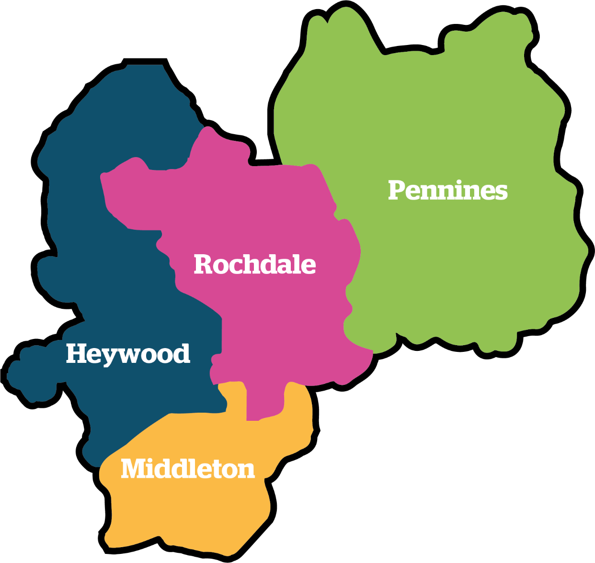

We look forward to hearing from you…

