ROMVP
Volunteer Advocate Information pack.

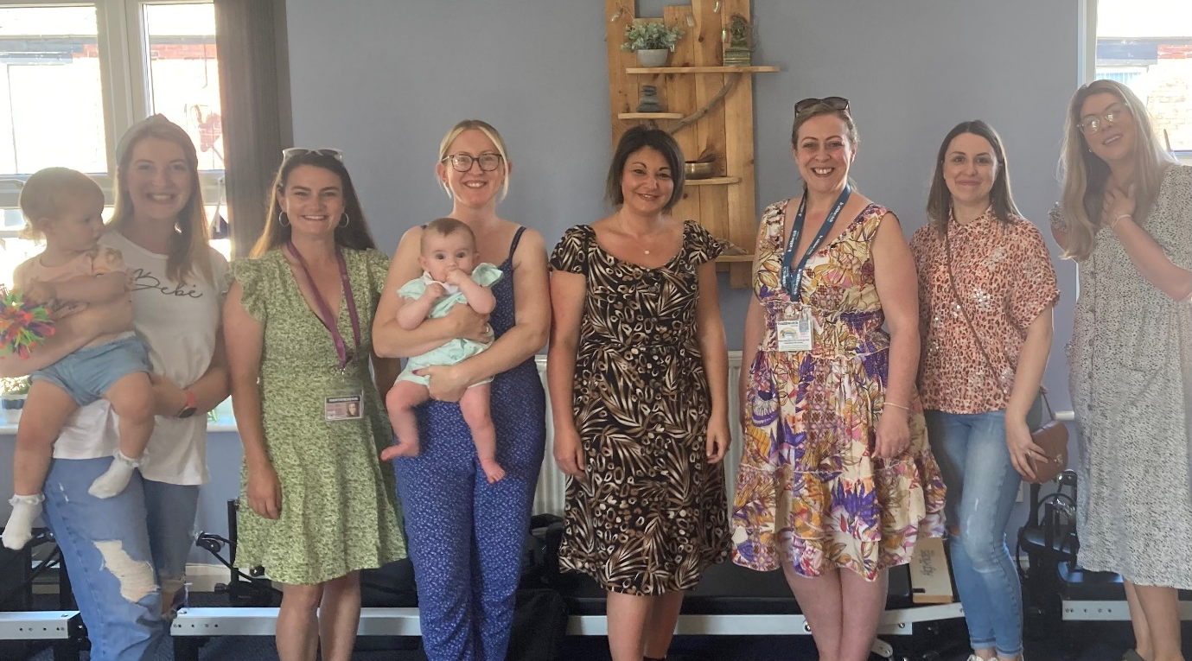

Hello and Welcome

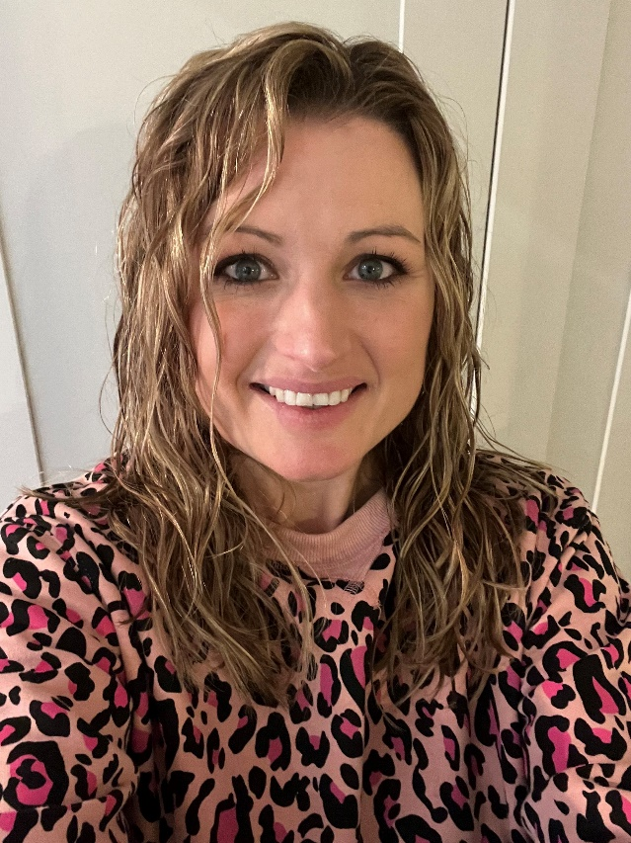

I’m the Engagement Facilitator for ROMVP. I worked as a secondary school teacher before changing careers and starting my own hypnobirthing business, Pea in the Pod Hypnobirthing. I love being a mum to my two daughters, Penelope & Daphne.
I feel passionately that birth can, and should be, a positive experience for all.
I really enjoy talking to people about their experiences and making sure this feedback is heard. I am also really impressed by how seriously the feedback is taken and I find it really rewarding seeing that changes are happening as a result of people sharing their experiences.
My role as Engagement Facilitator is to create as many opportunities as possible for people to engage with us and tell us their stories. I also use the ROMVP social media to try and reach as many people as possible. As part of my role, I also co-ordinate our amazing team of volunteer advocates.
In my spare time I love travelling, reading and Pilates. Though in recent years I’ve been getting my exercise in by constantly picking up toys and frantically searching for things that my toddler has hidden!

Ruth Wookey, ROMVP Engagement Facilitator

As Rochdale and Oldham MVP Chair I will be the point of contact for service users to provide feedback and will chair regular MVP meetings. I work closely with maternity services, Integrated Care Board members, and other partners to ensure the voices of Rochdale and Oldham’s service users are heard.
I am a local mother of 3, qualified by personal experience and have accessed a range of local maternity services. My professional background is in Finance and I have vast experience of representing stakeholders in front of the Board of Directors and multi-disciplinary panels.
I am extremely passionate that every birthing person should feel empowered, informed, and supported to enable them to enjoy what should be one of the most magical journeys into parenthood. My aim is to help improve maternity care so that more people are able to look back upon their pregnancy journey with great pride and fondness at one of the most monumental events in a persons life.
Leona Barlow, ROMVP lead

Introduction to Healthwatch
Healthwatch England
“Healthwatch” was set up in 2013 as a result of the Health and Social Care Act 2012, and the Healthwatch network consists of 151 Healthwatch’s across England, supported by Healthwatch England.
Healthwatch England is the independent national champion for people who use health and social care services. They’re here to make sure that those running services, and the government, put people at the heart of care.
Their sole purpose is to understand the needs, experiences and concerns of people who use health and social care services and to speak out on their behalf across England.
Their focus is on ensuring that people’s worries and concerns about current services are addressed and they work to get services right for the future.

Healthwatch Rochdale
Healthwatch Rochdale is an independent voice for the people of the Rochdale borough. They are here to listen to the experiences of Rochdale borough residents and give them a stronger say in influencing how local health and social care services are provided.
They listen to what people have to say about their experiences of using health and social care services across the Rochdale borough and feed this information through to those responsible for providing the services locally. They also ensure services are held to account for how they use this feedback to influence the way services are designed and run.
www.healthwatchrochdale.org.uk
Healthwatch Rochdale Mission Statement
“We are the independent voice of Heywood, Middleton and Rochdale residents. We listen, challenge and shape local health and social care services.”

Link with the Rochdale and Oldham Maternity Voices Partnership (ROMVP)
The Rochdale and Oldham Maternity Voices Partnership complements the existing work that Healthwatch do in helping to ensure that people’s experiences of care are used to help shape and improve services locally.
Healthwatch Rochdale is supported in its role with the Rochdale and Oldham Maternity Voices Partnership by Healthwatch Oldham.
The Role of ROMVP Advocate (Volunteer)
The voluntary role of ROMVP Advocate is flexible and led by your passions and interests.
Person specification
A ROMVP Volunteer Advocate will be expected to:
- Be committed and enthusiastic
- Be Passionate about maternity care and services
- Have excellent communication skills
- Demonstrate kindness and empathy
- Be proactive in engagement opportunities
- Endeavour to ensure all voices are heard from both Rochdale and Oldham service users
- Act in accordance with the Nolan Principles of conduct in public life in carrying out this role – selflessness, integrity, objectivity, accountability, openness, honesty and leadership
- Ensure that the ROMVP Terms of Reference is always followed
- Adhere to the code of conduct for Maternity Voice Partnership Members
- Maintain Confidentiality
http://nationalmaternityvoices.org.uk/privacy/

As a ROMVP Advocate you could be asked to support the MVP Lead or Engagement Facilitator with the following:
- Participation in feedback sessions: Take part in the collection of direct feedback from current maternity users from a wide range of settings
http://nationalmaternityvoices.org.uk/toolkit-for-mvps/gathering-feedback/walk-the-patch/

- Publicity and promotion: Raise awareness locally about the work of the ROMVP. Sharing information at events.
Signpost any enquiries or feedback to the Rochdale and Oldham MVP, Healthwatch Rochdale or Healthwatch Oldham.
Re-Share digital activity from the Rochdale and Oldham MVP social media accounts.
Share links to any online surveys via social media or relevant contacts.

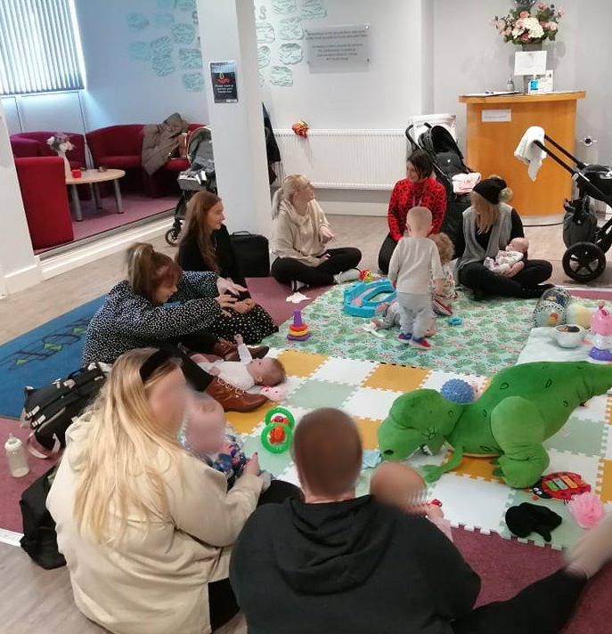
- Engagement: Help to create a safe space to support people who are sharing their stories to enable them to feel confident to speak and show flexibly to find the most appropriate way to communicate with them according to their needs.
Actively encourage seldom heard voices to be involved from both Rochdale and Oldham.

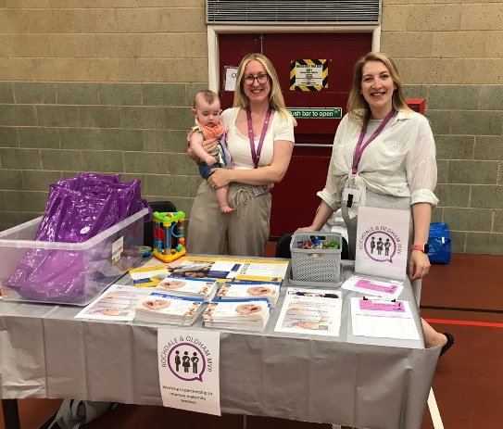
As a ROMVP Volunteer Advocate, some of the things you may be involved in are:
- Participate in ROMVP quarterly meetings, currently online.
- Helping to analyse feedback gathered
- Participate in engagement in Rochdale and/or Oldham
- Take part in Volunteer Advocate meet ups (in person or via Zoom)

What will you get out of volunteering?
- Be the active voice for people in your community
- Help to facilitate positive change across maternity services in Rochdale and Oldham
- A chance to upskill via bespoke training
- Personal Development
- Build skills for your CV
- Influence future maternity services via co-production
- A chance to connect to other, like-minded people, service users and expand knowledge on areas of personal interest
- Be part of a great group of volunteers
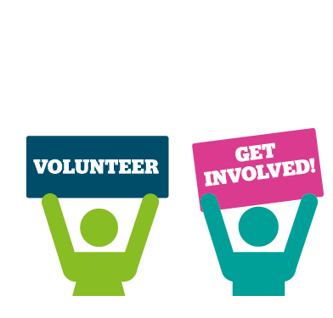

Volunteer ROMVP Advocate Recruitment process
Application and Monitoring Form
Please see the separate application form for the role of ROMVP Advocate. This must be completed in full and returned to info@healthwatchrochdale.org.uk
Please also complete and return the Monitoring form, this is not used as part of your application but helps us to monitor our recruitment for the Rochdale and Oldham Maternity Voices Partnership across Rochdale and Oldham.
If you require any of this information in a different format, please let us know.

Induction via Zoom
If your application is suitable for the role of a ROMVP Advocate, we will contact you to offer you a place on our online induction via Zoom.
This will give you an overview of Healthwatch Rochdale and the Rochdale and Oldham Maternity Voices Partnership as well as an insight into the work that is carried out and the groups priorities. The Zoom Induction is for approximately 1 hour.
If Zoom is not a suitable platform, we can look at alternative induction arrangements.

References and New Starter paperwork
Once the Induction has taken place, we will contact your two references from your application form and also send you the “new starter” ROMVP advocate paperwork to complete.

ROMVP Volunteer Advocate WhatsApp Group
If you are in agreement, you will also be added to the ROMVP Volunteer Advocate WhatsApp Group. This is a way to keep informed about the ongoing work of the ROMVP and updates as well as getting to know your fellow Advocates.

ROMVP Advocate Travel Expenses
The ROMVP values its volunteers and wants to ensure that there are no barriers to volunteer involvement. Expenses for travel may be claimed back (Day saver ticket for public transport or 45p per mile car travel).
To claim travel expenses, a ROMVP Volunteer Advocates expenses form must be completed, and relevant receipts or public transport tickets attached.
The Chief Executive Officer of Healthwatch Rochdale must countersign this form to authorise payment of these expenses as laid out in HWR Expenses Reward and Recognition Policy. The preferred method of payment is by BACS, however a cheque can be issued where necessary but may take longer.
Please email any expense claims or queries to naomi.burke@healthwatchrochdale.org.uk

Multi-media Platforms
Please follow our social media platforms and check out our website for updates, news and information.
- Twitter Page @ro_mvp
- Instagram Account ro_mvp
- Facebook Page https://www.facebook.com/RochdaleOldhamMVP
- Rochdale and Oldham MVP Web page https://healthwatchrochdale.org.uk/maternity-voices-partnership
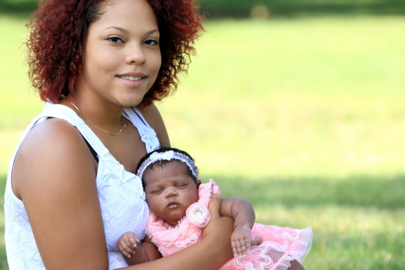
- Contact Email address info@romvp.org.uk

