Useful additional information and support
This information sets the context for some of the work of the Rochdale and Oldham Maternity Voices Partnership (ROMVP). It is not necessary to be familiar with all this information to be an effective ROMVP Advocate, but is good to know where to go for further information if you want to.
National policy context
The purpose of our Local Maternity and Neonatal System (LMNS) is to meet and deliver the recommendations of:
· Better Births, National Maternity Review. NHS England (February 2016)
· Saving Babies Lives. NHS England (March 2016)
These strategies are often mentioned at ROMVP meetings, and it can be useful to have a level of understanding of what they are. The summaries below provide a brief overview and should be detailed enough to help you follow any discussion.
If you are interested and wish to do any further reading then additional information about Better Births, Saving Babies Lives, Maternal and New-born Health Safety Collaborative reports and the Maternity Transformation Programme is available at https://www.england.nhs.uk/mat-transformation/saving-babies/ however reading up on these subjects really isn’t necessary for you to be an effective ROMVP Advocate.

Better Births
A National Maternity Review was commissioned as part of the NHS Five Year Forward View and the review findings were published in February 2016 as ‘Better Births’. ‘Better Births’ sets out wide ranging proposals designed to make care safer and give women greater control and more choices. Whilst there have been significant improvements in the quality of care, despite an increasing birth rate and increasingly complex cases, the review identified meaningful differences across the country, and further opportunities to improve the safety of care and reduce stillbirths. Prevention and public health have key roles to play, particularly around maternal smoking and obesity.
There are seven key priorities to drive improvement and ensure women and babies receive excellent care wherever they live.
  - Personalised care
  - Continuity of carer
  - Safer care
  - Better postnatal and perinatal mental health care
  - Multi-professional working
  - Working across boundaries
  - A fair and adequate payment system

Saving Babies Lives version 2
Saving Babies’ Lives is a care bundle designed to support providers, commissioners, and healthcare professionals to take action to reduce stillbirths. Saving Babies’ Lives is designed to tackle stillbirth and early neonatal death. It brings together four elements of care that are recognised as evidence based and/or best practice:
1. reducing smoking in pregnancy
2. risk assessment and surveillance for fetal growth restriction
3. raising awareness of reduced fetal movement
4. effective fetal monitoring during labour
5. Reducing premature labour.

Maternal & Newborn Health Safety Collaborative
A three-year programme to support improvement in the quality and safety of maternity and neonatal units across England. The programme aims to make measurable improvements in safety outcomes for women, their babies and families. The national maternal and neonatal health safety collaborative will help all maternity care providers and commissioners to:
· Improve clinical practice;
· Reduce unwarranted variation;
· Report on how they are contributing to achieving the national ambition.
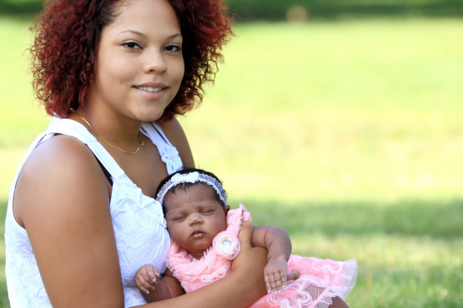

Glossary of terms/abbreviations
Head of Midwifery (HoM)
Person responsible for leading the maternity profession. The postholder will normally report to the Chief Nurse who represents midwifery on the Board. The job often incorporates responsibility for gynaecology and infertility services.
Director of Midwifery (DoM)
Person responsible for leading the maternity profession locally and at the Trust Board.

Medical Director
A doctor who leads the medical profession for a division (group of services such as Women and Children’s services) or the whole Trust.
Business Manager/Directorate Manager/Divisional Director of Operations
Person responsible for ensuring the income and expenditure is managed in a business unit, e.g. women & children’s services. Also responsible for delivering the contract activity agreed over a financial year.
Obstetrician
Medical doctor who has specialised in obstetric care looking after women during the antenatal, intra partum and postnatal period. This normally concludes up to 6 weeks post-delivery.
Neonatalogist
Doctor who specialises in looking after pre-term and sick babies in the Neonatal Unit/post natal ward and up to the first year of life.
Consultant Midwife
A senior midwife who can carry her own caseload but who normally leads clinical development and research in midwifery care.
Safeguarding children
The legal process in place to protect children from harm. Harm can be emotional, physical and psychological.
Safeguarding adults
The legal process to protect adults (over 18) from harm.
DOLS
Deprivation of liberty act, used when an adult has been identified as having no capacity to make decisions.
Care Quality Commission
(CQC) The organisation which completed independent quality reviews of whole organisations in healthcare. These include primary care, acute secondary care, mental health and care homes.
NHS England and NHS Improvement (NHSE/I)
This is the result of two organisations created during the Lansley reforms now being merged. NHSE/I is responsible for commissioning and monitoring the quality of care delivered for England. The national strategy is set by NHSE/I and the Chief Executive reports to the Secretary of State for Health.
Local Maternity & Neonatal System (LMNS)
The body created as part of the national maternity strategy ‘Better Births’ to deliver an integrated vision across traditional organisational boundaries to allow pregnant women to have choice, care close to home, continuity of carer and to support the reduction in stillbirth, neonatal death, neonatal brain injury and maternal death. The LMNS employs project leads, doctors, midwives and other professions to deliver the objectives set by the MVP and the commissioners.
Continuity of Carer (CoC)
Care delivered as one midwife looking after a caseload of 36 women throughout their whole pregnancy, birth and postnatal period; or a small group of 4 to 6 midwives looking after 216 women, i.e. 36 women each, but the women will know each midwife who will give care during the antenatal, intra partum and postnatal period.

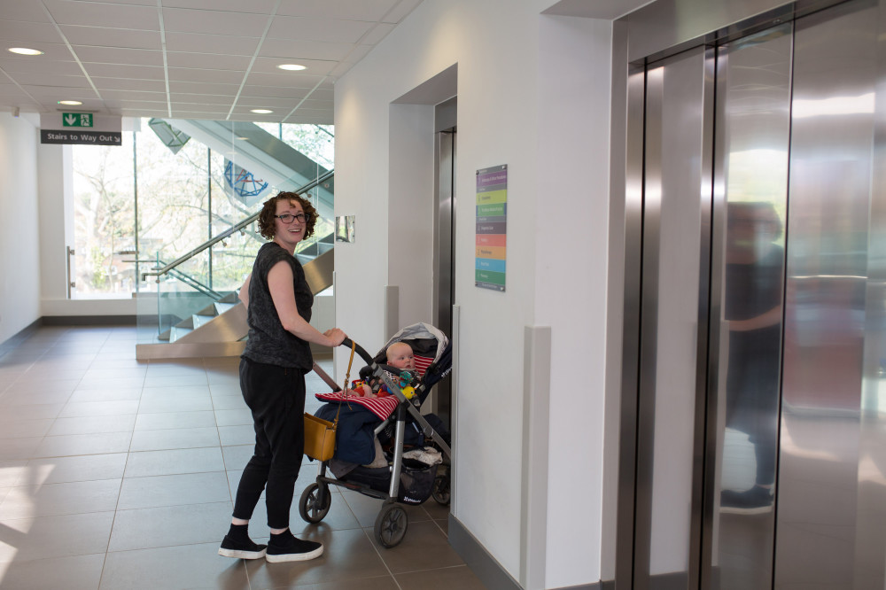
For more information please email info@romvp.org.uk

