Youthwatch Rochdale Volunteer
Role Description

Youthwatch Volunteer
Introduction
Healthwatch Rochdale is the independent champion for Health and Social Care in Rochdale. We give people a voice to help improve the design of local services as well as help to make the right choices about the services they receive.
Healthwatch Rochdale relies on the experiences of service users, their families and carers to help identify poor quality services, gaps in provision and good practice.

Role Description
A Youthwatch Volunteer plays a key role in assisting Healthwatch Rochdale by gathering health and social care feedback for the 13-18 years age group.
Our Youthwatch Volunteers help collect feedback locally around health and social care, as well as promoting the services of Healthwatch Rochdale within this age group.
Your role may also be to help us develop media items such as branded images, posters and leaflets.

Key Tasks
- Act as a link between Healthwatch Rochdale and young people
- Promote Healthwatch Rochdale and the work we do
- Take part in a monthly online meeting and surveys
- Talk to, and gather information from, young people on their experiences of Health and Social Care within Rochdale
- Identify local and national news stories of interest around Health and Social Care and bring them to the attention of Healthwatch Rochdale
- Promote and share Healthwatch Rochdale’s social media platforms

Personal Attributes
You do not need any specific experience or knowledge to be a Youthwatch Volunteer. Instead, we ask that our members can demonstrate the following attributes:
- Good listening and verbal communication skills
- Be approachable and personable
- Confident to talk to new people
- Able to maintain confidentiality and protect personal data
- Good written communication skills including the ability to take notes and write up conversations
- Be open minded and non-judgemental
- Have an interest in Health and Social Care
- Passionate about making a difference to the lives of local people and your community
- Committed to volunteering on a regular basis and undertaking basic training relevant to the role
Time Commitment
There is no minimum commitment required however we would recommend at least 2-4 hours per month to maximise the experience you will gain from this role.
Location
Within your own community and locally where you live. We could also ask you to take part in engagement across the Rochdale Borough – but only where you are happy to travel to. The monthly meetings are currently run virtually via Zoom.
What will you get in return for volunteering with Youthwatch Rochdale?
Reasonable travel and out of pocket expenses will be reimbursed in accordance with our expenses policy, and if you attend 5 meetings you will receive a £25 voucher.
- Training – online e-learning Introduction to Healthwatch
- Enjoy the experience of volunteering as part of a small friendly team and meeting new people
- Become involved in making a difference in your local community
- Increase your confidence and gain new skills
- Use your experience with Healthwatch to seek work in health and social care or other fields of employment
- Learn more about Health and Social Care delivery in the borough of Rochdale
- Rewards and Recognition – Certificates, incentives and References as an example
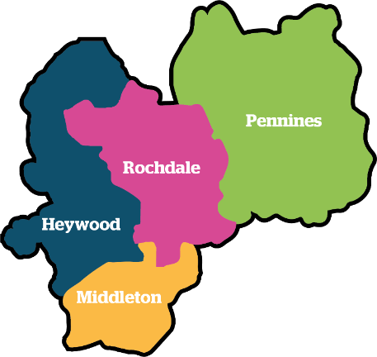
Would you like to volunteer with us?
If you are aged between 13 and 18 years old and live, work, study or access services in the borough of Rochdale, you can apply by completing the application form available upon request.
Please email info@healthwatchrochdale.org.uk for more information or an informal chat about this role.

