Youthwatch Rochdale – What’s it all about?
Who are Healthwatch Rochdale?
We want to help make all health and social care services better in the Rochdale Borough. We speak to Rochdale residents and use what they tell us, to make services right for you, your friends and family.

What is Youthwatch?
Youthwatch Rochdale is open to anyone between the ages of 13 and 18 years old who live, work, study or access services in the Rochdale Borough
Youthwatch Rochdale is here to listen to you. We use what you tell us to make a difference to local services for young people.
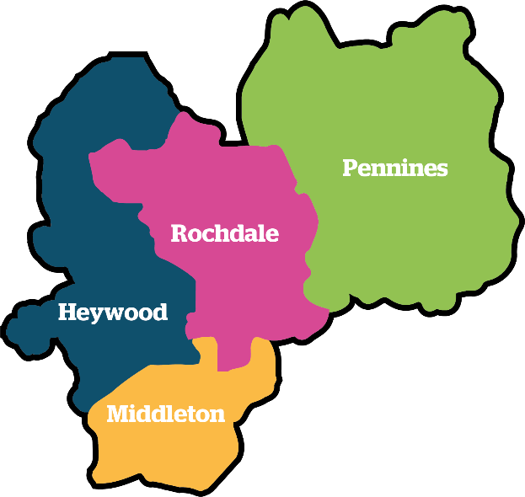
Our Aim:
Our aim is to work with the young people from the Rochdale Borough listening to what matters to them, giving them greater voice and inclusion.

What does Youthwatch do?
Youthwatch Rochdale Volunteers:
- Meet monthly online via Zoom
- Take part in Youthwatch 100 surveys
- Gather in feedback from their friends and family
- Meet with Schools, Groups and Organisations

What’s in it for You?
- Voucher of own choice once attended 5 meetings
- Enter our #YW100 surveys with a chance to win a £20 voucher
- Develop a variety of skills
- Build your understanding of health and social care services
- Certificates of recognition and references for time spent with us
- Being part of a valued team of young people
- Build up your CV
- Being able to have a say on local matters
- Training Opportunities
- Make new friends
- Help to support the improvement of services specifically for young people
What we need from you:
- When possible, to attend our monthly meetings via Zoom
- Participation in Youthwatch activities
- Help to get feedback from local young people
- Promote Healthwatch Rochdale and what we do
How will You be supported?
- Our Engagement and Volunteer Manager will support you in this role
- We will help you to log your time so that you can benefit from the Voucher Reward Scheme
- We can come to your school, group or organisation
Any Questions:
Please contact us -
Healthwatch Rochdale, No 2 The Esplanade, Second Floor Suite 5, Rochdale OL16 1AE
Tel: 01706 249 575 Email: info@healthwatchrochdale.org.uk

